Experiment 3

Association Rule Mining on contact-lenses Dataset

Aim: To demonstrate Association rule mining process on predefined Weka dataset contact-lenses.arff using Apriori algorithm.

Tasks:

1. Load contact-lenses.arff dataset and explore it.
2. Apply Apriori algorithm with default parameters.
3. Change the parameters and observe the results

Task 1: Load contact-lenses.ariff dataset and explore it.

Go to Explorer 🡪 OpenFile 🡪 Browse C:/Program Files/Weks-x-x-x/data 🡪 open contact-lenses.arff file.

Observations:

|  |  |
| --- | --- |
| Attribute | States and their meaning |
| age |  |
| spectacle-prescript |  |
| astigmatism |  |
| tear-prod-rate |  |
| contact-lenses |  |

Task 2: Apply Apriori algorithm with default parameters

Association Rule Mining is a process that finds features which occur together or features that are correlated. Popular applications are Market Basket Analysis and Cross Marketing.

Association rules are mined out after frequent itemsets in a big dataset which can be found using algorithms such as Apriori and FP Growth.

Frequent Itemset mining mines data using support and confidence measures.

$$support \left(A⇒B\right)=\frac{number of instances containing both A and B}{total number of instances}$$

$$confidence \left(A⇒B\right)=p\left(B/A\right)=\frac{number of instances containing both A and B}{number of instances containing A}$$

Apriori Rule Learner in Weka implements Apriori algorithm. It iteratively reduces the minimum support from its upperBound until (i) it finds the required number of rules or the minimum support reaches lowerBound.

Default values of the some important parameters:

lowerBoundMinSupport = 0.1 (10%)

upperBoundMinSupport = 1.0 (100%)

metricType = Confidence

minMetric = 0.9 (90%)

numRules = 10

Steps:

* + - 1. Select Associate 🡪 Choose 🡪 associations 🡪 Apriori.
      2. Observe the default parameter values.
      3. Click on Start.



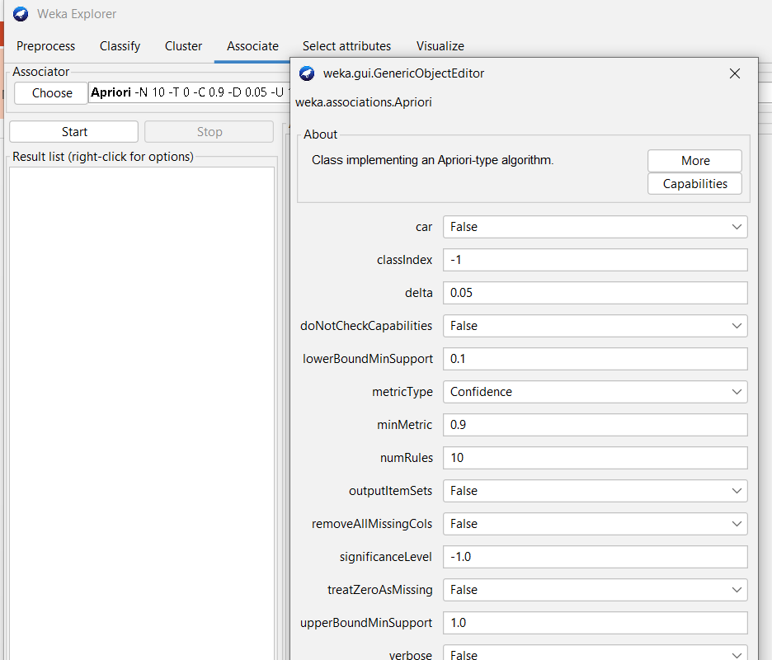

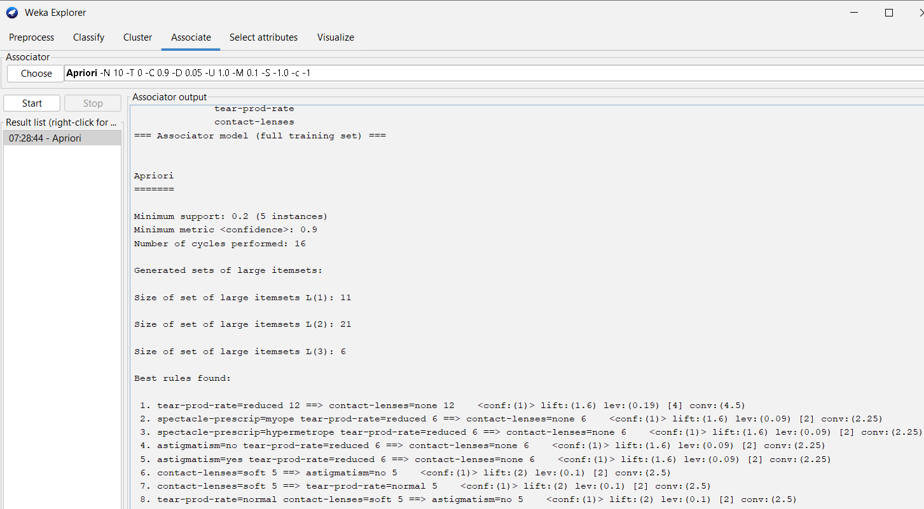

Observations:

|  |  |
| --- | --- |
| **Default Parameters** | **Observations** |
| lowerBoundMinSupport =  upperBoundMinSupport =  metricType =  minMetric =  numRules = | Minimum support =  Minimum Metric <Confidence> =  Number of cycles performed =  Best rules found with confidence:  1.  2.  3.  4.  5.  6.  7.  8.  9.  10. |

Task 3: Apply Apriori algorithm with required parameters

Observations: Change the default parameter values and perform the experiment

|  |  |
| --- | --- |
| **Parameters** | **Observations** |
| lowerBoundMinSupport =  upperBoundMinSupport =  metricType =  minMetric =  numRules = | Minimum support =  Minimum Metric <Confidence> =  Number of cycles performed =  Best rules found with confidence: |

Conclusion: